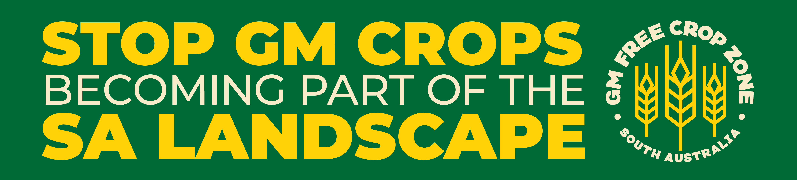

Name:
Address:
Phone:
Email:

Date:

To the Mayor and Councilors of …………………. Council
Address:
Email:

Re: Please ensure our region remains a GM-free Crop Zone

Dear Mayor and Councilors:

Please do everything you can to ensure that our Council area remains a GM-free Crop Zone. Losing South Australia's GM-free status and reputation for high quality GM-free food products will disrupt food markets and deny us trade benefits, in our council area and state-wide.

I request council to embrace the GM-free Crop Zone review process and to marshal community resources to apply for and establish a GM-free Crop Zone here.
Please resolve to:
- consider our council area remaining a GM-free Crop Zone;
- consult everyone in our community - including farmers and food processers;
- apply to the Minister for Primary Industries to remain a GM-free Crop Zone.

We have the opportunity to copy Kangaroo Island which will remain GM-free to keep earning big premiums for their GM-free grains and beverages, in local and export markets. KI Pure Grain benefits from selling its non-GM canola for over $3,000,000 and other grains as 'GM Free'.

The Palsystem Consumers' Co-operative Union of Japan is strictly non-GM so buys canola and honey worth $6 million only from Kangaroo Island. The Co-op has, “a plan to expand our range and volume of non-GM products, but the extension of the moratorium is critical to this plan.”

Another GM-free Japanese Consumer Co-operative, Coop Shizenha, has over 142,000 members, It also wants to keep “purchasing agricultural products cultivated in South Australia and Kangaroo Island as the only remaining Non-GM cultivation area of your country.”

CSIRO team leader Dr Sandra Eady and Australian Export Grains Innovation Centre chief economist Ross Kingwell told the rural media, "We've achieved a $100 million per year premium for our farmers, given the extra $20-$40/tonne paid for Australian non-GM Australian canola.”

In the week ending June 5, 2020, GM canola was discounted $95/tonne in WA compared with non-GM varieties, $39/tonne in Port Melbourne, and up to $39/tonne in rural NSW.

A GM-free Crop Zone in our area is a chance too good to miss. Please do the best you can to ensure it happens, for the benefit of our community.

Yours sincerely,

